27/06/2016
SURVEY OF THE BALANCE SHEET OF MONETARY FINANCIAL INSTITUTIONS, MAY 2016
Over the month, the Bank of Lithuania’s holdings of debt securities issued by euro area residents and loans to euro area residents increased by EUR 336.9 million and EUR 3.2 million respectively. These indicators amounted to EUR 4.4 billion and EUR 591.5 million respectively at the end of the month. Euro area resident deposits held with the Bank of Lithuania over the month increased by EUR 553.7 million — to EUR 4.0 billion. Loans of other monetary financial institutions (MFIs) to Lithuanian residents, excluding MFIs, increased by EUR 321.0 million, to EUR 18.0 billion at the end of the month. The deposits of Lithuanian residents, excluding MFIs, with other MFIs decreased by EUR 100.0 million — to EUR 16.8 billion. Loans of other MFIs to Lithuanian households for house purchase, consumption and other purposes increased by EUR 43.5 million, EUR 9.2 million and EUR 20.4 million respectively over the month.
Survey of the balance sheet of the Bank of Lithuania
Euro area external assets increased by EUR 285.1 million, while external liabilities dropped by EUR 10.1 million over the month. At the end of the month, these indicators amounted to EUR 1.8 billion and EUR 256.3 million respectively.
Over the month, the holdings of debt securities issued by euro area residents and loans to euro area residents increased by EUR 336.9 million and EUR 3.2 million respectively — to EUR 4.4 billion and EUR 591.5 million respectively. Over the month the Bank of Lithuania’s holdings of investment fund units/shares, issued by euro area residents, contracted by EUR 22.0 million, while holdings of equity instruments remained unchanged. At the end of the month these indicators amounted to EUR 482.6 million and EUR 207.2 million respectively.
Currency in circulation (the definition is provided in the section ‘Notes’ of this Survey) grew by EUR 23.0 million over the month, to EUR 5.9 billion at the end of the month. Euro area resident deposits held with the Bank of Lithuania over the month increased by 553.7 million — to EUR 4.0 billion. The Bank of Lithuania’s capital and reserves grew by EUR 0.9 million, amounting to EUR 740.8 million at the end of the month.
Survey of the Balance Sheet of Other MFIs
Loans to Lithuanian residents, excluding MFIs, grew by EUR 321.0 million over the month, as loans to non-financial corporations, households, investment funds and other financial intermediaries, as well as loans to general government grew by EUR 217.1 million, EUR 73.1 million, EUR 30.7 million and EUR 0.5 million respectively — to EUR 8.1 billion, EUR 8.0 billion, EUR 1.0 billion and EUR 890.4 million respectively at the end of the month. Loans to insurance corporations and pension funds contracted by EUR 0.3 million, to EUR 3.4 million at the end of the month.
Loans to Lithuanian non-financial corporations with the initial maturity of up to 1 and from 1 to 5 years increased by EUR 7.3 million and EUR 268.6 million respectively, while loans with a maturity over 5 years decreased by EUR 58.9 million. At the end of the month, loans to non-financial corporations with an agreed maturity of up to 1 year, of over 1 up to 5 years, and of over 5 years amounted to EUR 1.1 billion, EUR 4.3 billion and EUR 2.6 billion respectively. Loans to Lithuanian households for house purchase, consumption and other purposes increased by EUR 43.5 million, EUR 9.2 million and EUR 20.4 million respectively over the month — to EUR 6.3 billion, EUR 691.4 million and EUR 948.2 million.
Holdings of debt securities of other MFIs issued by Lithuanian residents, excluding MFIs, decreased by EUR 55.8 million over the month, while holdings of equity instruments remained unchanged. At the end of the month, these indicators stood at EUR 1.2 billion and EUR 340.4 million respectively.
Chart 1. Loans of other MFIs to Lithuanian residents, excluding MFIs
(outstanding amounts, end-of-period)
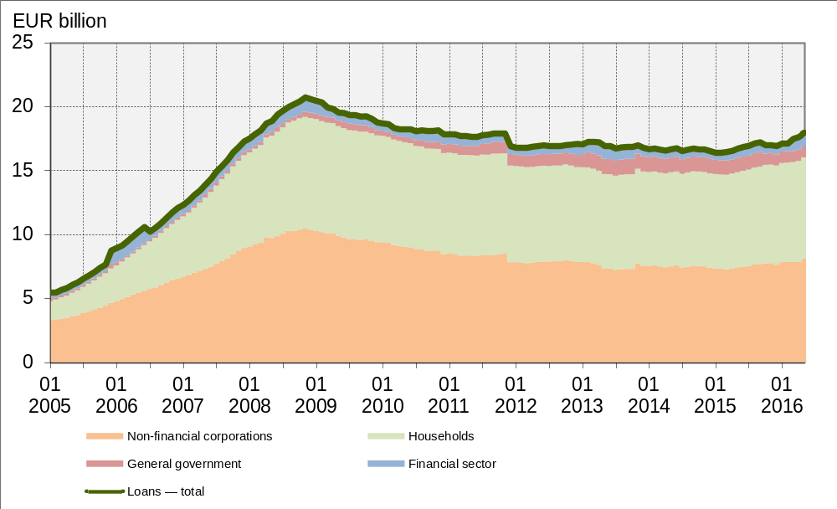
Source: Bank of Lithuania.

The deposits of Lithuanian residents, excluding MFIs, decreased by EUR 100.0 million — to EUR 16.7 billion at the end of the month. Overnight deposits, deposits with agreed maturity and deposits redeemable at notice contracted by EUR 51.5 million, EUR 41.5 million and EUR 7.1 million respectively. Deposits of non-financial corporations and households decreased by EUR 230.0 million, while deposits of the general government sector, investment funds and other financial intermediaries, as well as insurance corporations and pension funds increased by EUR 114.6 million, EUR 11.6 million and EUR 3.8 million respectively — to EUR 1.2 billion, EUR 173.0 billion and EUR 270.0 million.
Chart 2. Deposits of Lithuanian residents, excluding MFIs
(outstanding amounts, end-of-period)
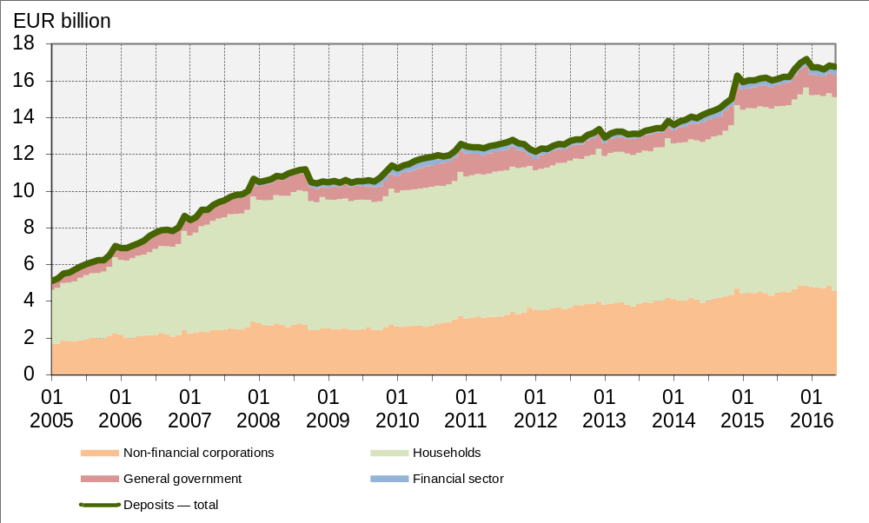
Source: Bank of Lithuania.

Overnight deposits, deposits with agreed maturity and deposits redeemable at notice of Lithuanian non-financial corporations contracted by EUR 267.0 million, EUR 16.7 million and EUR 4.6 million respectively over the month — to EUR 4.5 billion, EUR 165.6 million and EUR 37.0 million respectively. Lithuanian households’ overnight deposits grew by EUR 84.0 million, while deposits with agreed maturity and deposits redeemable at notice decreased by EUR 23.2 million and EUR 2.5 million over the month. At the end of the month, these household deposits amounted to EUR 6.6 billion, EUR 3.7 billion and EUR 221.5 million respectively.
Deposits of Lithuanian non-financial corporations with an agreed maturity of up to 1 year, of over 1 up to 2 years and of over 2 years decreased by EUR 10.1 million, EUR 5.8 million and EUR 0.7 million respectively over the month — to EUR 86.7 million, EUR 60.4 million and EUR 18.6 million respectively at the end of the month. Deposits of Lithuanian households with an agreed maturity of up to 1 year contracted by EUR 37.6 million, while deposits with an agreed maturity of over 1 and up to 2 years and of over 2 years increased by EUR 11.1 million and EUR 3.3 million respectively. At the end of the month, household deposits with an agreed maturity of up to 1 year, of over 1 and up to 2 years and of over 2 years amounted to EUR 2.7 billion, EUR 748.4 million and EUR 281.0 million respectively.
Notes
- Unless otherwise specified, monthly changes in euro are presented in the Survey as transactions, i.e. they are calculated by taking the difference between end-of-month outstanding amounts and then removing the effects of revaluation adjustments, exchange rate adjustments, writing loans off and reclassifications.
- Currency in circulation (definition for statistical purposes) — the share of the Bank of Lithuania in the Eurosystem’s total issue of euro banknotes and the euro coins issued by the Bank of Lithuania. The total value of euro banknotes is allocated to each central bank, a participant of the Eurosystem, by applying the subscribed capital key, as provided for in the 13 December 2010 Decision ECB/2010/29 on the issue of euro banknotes (and its subsequent amendments). Until December 2015 currency in circulation included litas banknotes and coins that had not been withdrawn from circulation.
- In Charts 1 and 2, the financial sector consists of Lithuania’s investment funds and other financial intermediaries, as well as insurance corporations and pension funds.
- For the terms used in the Survey and detailed data see the website of the Bank of Lithuania (http://www.lb.lt/methodological_notes_2).

Statistics Department
Economics and Financial Stability Service

